Category-wise Product Analysis Report

1. Title
Category-wise Product Analysis Report

2. Objective
The objective of this submission is to analyze the products stored in the E-Commerce Database based on their categories.
The analysis helps to understand:
- Products available under each category
- Number of products in each category
- Highest-priced product in each category
- Categories having more than 5 products
- Average product price for each category

3. List Products by Category
This query displays the products along with their category, price, and stock quantity.
SQL Query:
SELECT c.Category_Name, p.Product_Name, p.Price, p.Stock_Quantity
FROM Category c
JOIN Product p ON c.Category_ID = p.Category_ID
ORDER BY c.Category_Name, p.Product_Name;
Result:
The products were successfully displayed category-wise.
Screenshot:
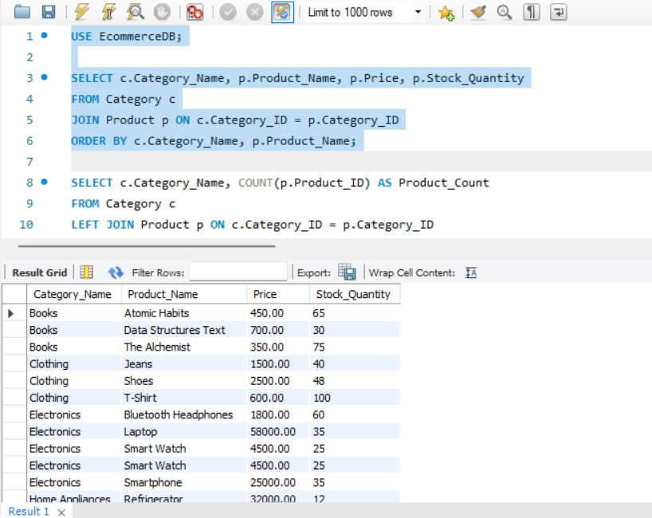

4. Count Products by Category
This query calculates the total number of products available in each category.
SQL Query:
SELECT c.Category_Name, COUNT(p.Product_ID) AS Product_Count
FROM Category c
LEFT JOIN Product p ON c.Category_ID = p.Category_ID
GROUP BY c.Category_ID, c.Category_Name;
Result:
The number of products in each category was successfully calculated.
Screenshot:
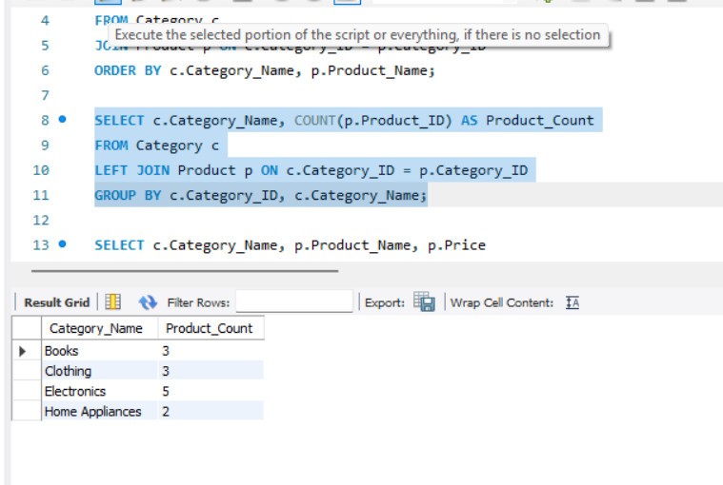

5. Highest-priced Product in Each Category
This query identifies the highest-priced product available in each category.
SQL Query:
SELECT c.Category_Name, p.Product_Name, p.Price
FROM Category c
JOIN Product p ON c.Category_ID = p.Category_ID
WHERE p.Price = (
SELECT MAX(p2.Price)
FROM Product p2
WHERE p2.Category_ID = p.Category_ID
);
Result:
The highest-priced product from each category was successfully identified.
Screenshot:
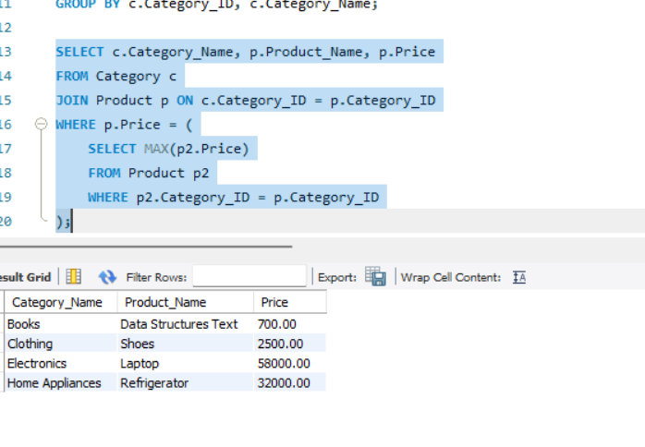

6. Categories with More Than 5 Products
This query identifies categories that contain more than 5 products.
SQL Query:
SELECT c.Category_Name, COUNT(p.Product_ID) AS Product_Count
FROM Category c
JOIN Product p ON c.Category_ID = p.Category_ID
GROUP BY c.Category_ID, c.Category_Name
HAVING COUNT(p.Product_ID) > 5;
Result:
The categories containing more than 5 products were successfully identified.
Screenshot:
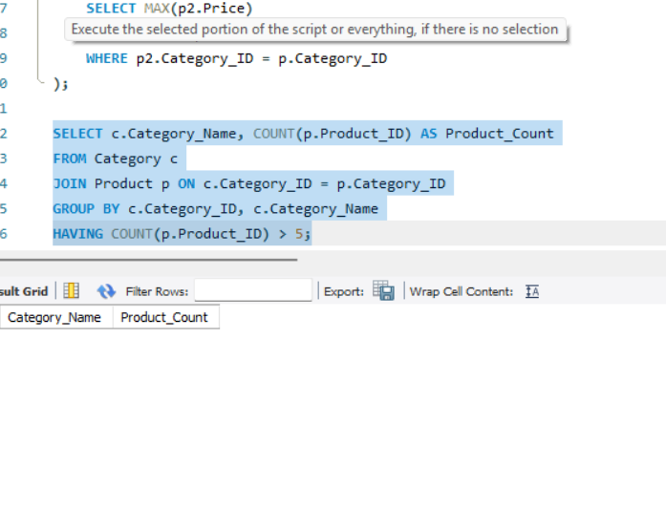

7. Average Price per Category
This query calculates the average product price for each category.
SQL Query:
SELECT c.Category_Name, AVG(p.Price) AS Average_Price
FROM Category c
JOIN Product p ON c.Category_ID = p.Category_ID
GROUP BY c.Category_ID, c.Category_Name;
Result:
The average price of products in each category was successfully calculated.
Screenshot:
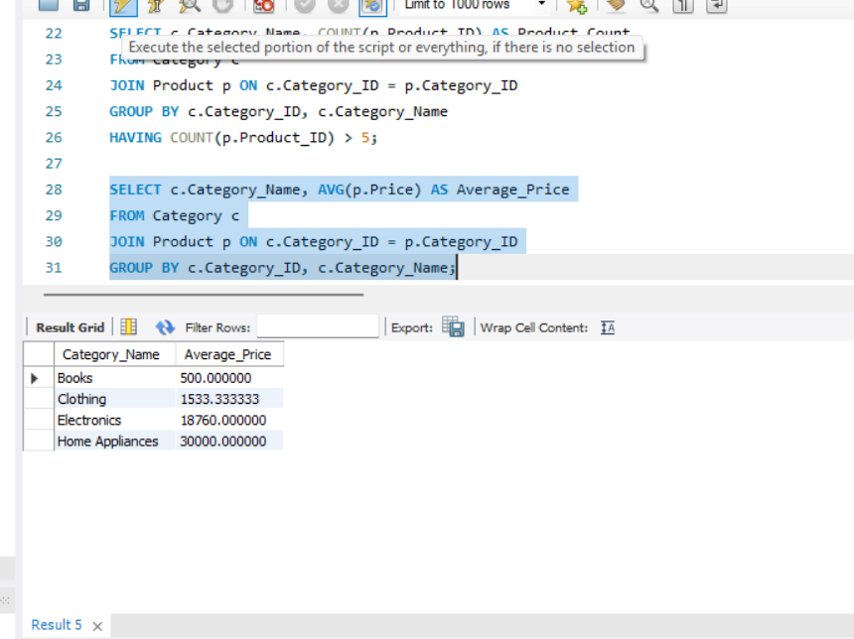

8. Final Result
The category-wise analysis was successfully performed using SQL queries. The analysis provided information about product distribution, product count, highest-priced products, categories with more than 5 products, and average prices.

